**INTERNAL PROJECT REPORT**

**Submitted to:** Department of Computer Applications

**College Name:** JG University

**Course:** BCA Semester 5

**Date of Submission:** 19th July 2025

**Class Mentor**: Javani Mam

**Designed by**:

1. **Jeet Gandhi 1017**
2. **Divy Rawal 1052**
3. **Prince Savaliya 1061**
4. **Kavya Sevak 1062**
5. **Saiyam Shah 1064**

Project Overview:

**Title:** ConnectFarma

**Tagline:** Bringing Farmers to Families.

**Project Type:** In-House

**Technology Stack:** HTML, CSS, JAVASCRIPT, PHP/Python, MySQL

**Index**

|  |  |  |  |  |  |  |  |  |  |  |  |  |  |  |  |  |  |  |  |  |  |  |  |  |  |  |  |  |  |  |  |  |  |  |  |  |  |  |  |  |  |  |  |  |  |  |  |  |  |  |  |  |  |  |
| --- | --- | --- | --- | --- | --- | --- | --- | --- | --- | --- | --- | --- | --- | --- | --- | --- | --- | --- | --- | --- | --- | --- | --- | --- | --- | --- | --- | --- | --- | --- | --- | --- | --- | --- | --- | --- | --- | --- | --- | --- | --- | --- | --- | --- | --- | --- | --- | --- | --- | --- | --- | --- | --- | --- |
| |  |  |  | | --- | --- | --- | | **Sr.No.** | **Section Title** | **Page No.** | | 0.1 | Cover Page & Submission Details | 1 | | 0.2 | Project Overview | 2 | | 0.3 | Index (Basic Table of Contents) | 3 | | 1.1 | Project Proposal & Planning | 4 | | 1.2 | Advantages of ConnectFrama | 5 | | 1.3 | Proposed System & Modules Overview | 6 | | 2.1 | System Design & Database | 7 | | 2.2 | System Diagram | 8 | | 2.3 | System Design Layout: Home Page | 9 | | 2.4 | UI Screens: SignUp/Login (Consumer & Farmer) | 10 | | 2.5 | Database Development – Consumer Table | 23 | | 2.6 | Database Development – Farmer Table | 24 | | 2.7 | Database Development – Product Table | 25 | | 2.8 | Modules Summary (Farmer, Customer, Admin, Order) | 26 | | 2.9 | Functional Details (User Registration, Login, Listing, Orders) | 27 | | 2.10 | Dashboard Features (Admin, Farmer, Consumer) | 28 | | 2.11 | Contact & Support + Final Flow Diagram | 29 | |

# Project Proposal & Planning

1. Project Title:

ConnectFarma – A Local Farmers Market Website

1. Problem Statement:
   1. Farmers face challenges in connecting directly with urban consumers due to the lack of digital platforms. This allows middlemen to take advantage, increasing their profits and selling products to consumers at a higher price. There is a need for a transparent, user-friendly platform to bridge this gap and facilitate direct transactions.
2. Existing System and Limitations:
   1. Offline Markets: Time-bound, location-specific, and lack reach.
   2. Existing Apps: Target large-scale agriculture or wholesalers, not local farmers.

**Limitations include:**

* 1. No direct communication channels between farmers and buyers.
  2. Lack of trust and verification.
  3. Poor UI for illiterate farmers.

Additionally, Platforms like Blinkit, Swiggy Instamart, and Zepto also offer vegetable and fruit delivery services. However, these services often encounter quality issues because their core business models are not centered around fresh produce.

Since selling vegetables does not generate high profits for these companies, they do not focus significantly on improving quality or supply chain efficiency in this area.

ConnectFarma is specifically designed for selling vegetables and fruits. Our platform directly involves local farmers in managing their inventory, ensuring freshness, accountability, and transparency. This farmer-centric model eliminates intermediaries, placing quality control in the hands of those who grow the product.

ConnectFrama aims to be a niche platform dedicated to vegetables and fruits—an area currently underserved by mainstream delivery apps.

**Advantages of ConnectFrama**:

1. **Direct Farmer-to-Consumer Link**  
   Farmers can sell their produce directly to customers without middlemen, ensuring better profits.
2. **Fresh and Quality Produce**  
   Since farmers manage their own stock, customers receive fresh fruits and vegetables with assured quality.
3. **Fair Pricing**  
   Eliminating intermediaries results in transparent and reasonable pricing for both farmers and buyers.
4. **Focus on Fruits & Vegetables Only**  
   Unlike other platforms, ConnectFrama is fully dedicated to the fruits and vegetable segment, ensuring specialized service.
5. **User-Friendly Platform**  
   Designed with simplicity in mind for both farmers and consumers, including easy registration and order management.
6. **Community Empowerment**  
   It supports local agriculture, boosts farmer income, and promotes healthy eating in urban areas.

**Key Features & Functionalities:**

1. Farmer Portal: Register, upload products, update stock/pricing.
2. Customer Portal: Browse, filter, search, and place orders.
3. Admin Panel: Manage users, products, and handle disputes.
4. Order System: Cart, payment, and delivery tracking.

**Modules and Sub-modules:**

|  |  |
| --- | --- |
| **Module** | **Sub-modules** |
| Farmer Module | Registration, Login, Product Upload, Order Tracking |
| Customer Module | Registration, Product Browsing, Add to Cart, Place Order |
| Admin Module | Approved Users, View Reports, Manage Listings |
| Order Module | Invoice Generation, Status Updates, Delivery Coordination |

### 1. **User Registration (Consumers & Farmers)**

Allows both consumers and farmers to sign up by providing basic details like name, email, contact number, and password. Validates input and securely stores user data in the database.

### **2**. **Login & Authentication**

Enables registered users to log in securely. Authenticates credentials and manages user sessions to personalize access to features.

### **3. Product Categories**

Displays farm product categories like fruits, vegetables, dairy, etc., with images and descriptions. Helps users easily browse what’s available.

### **4.** **Product Listing & Details**

Farmers can upload products with names, prices, and images. Consumers can view product details, availability, and prices before ordering.

### **5.** **Order Placement & Cart**

Consumers can add items to their cart, review the list, and place an order. The cart system helps manage multiple items and total cost calculations.

### **6.** **Admin Dashboard**

Provides control to monitor users, products, and orders. Admin can approve farmer accounts, manage data, and ensure smooth operations.

### **7.** **Farmer Dashboard**

Farmers can manage their profile, add or edit product listings, and track orders received. It simplifies their selling process.

### **8.** **Consumer Dashboard**

### Consumers can view past orders, track current ones, and manage their profile. Gives a clear overview of their buying activity.

### **9.** **Contact & Support**

A contact page for consumers or farmers to raise questions or concerns. Ensures good communication and trust in the platform.

**System Design & Database Development &**

**Data Dictionary**

**System Diagram**

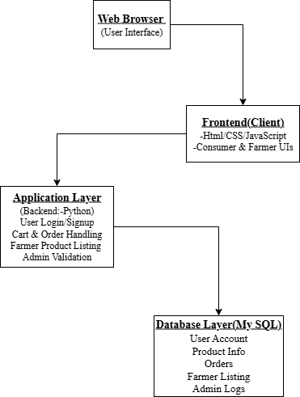

**System Design**

**Design Layout ::**

1. **Home Page**

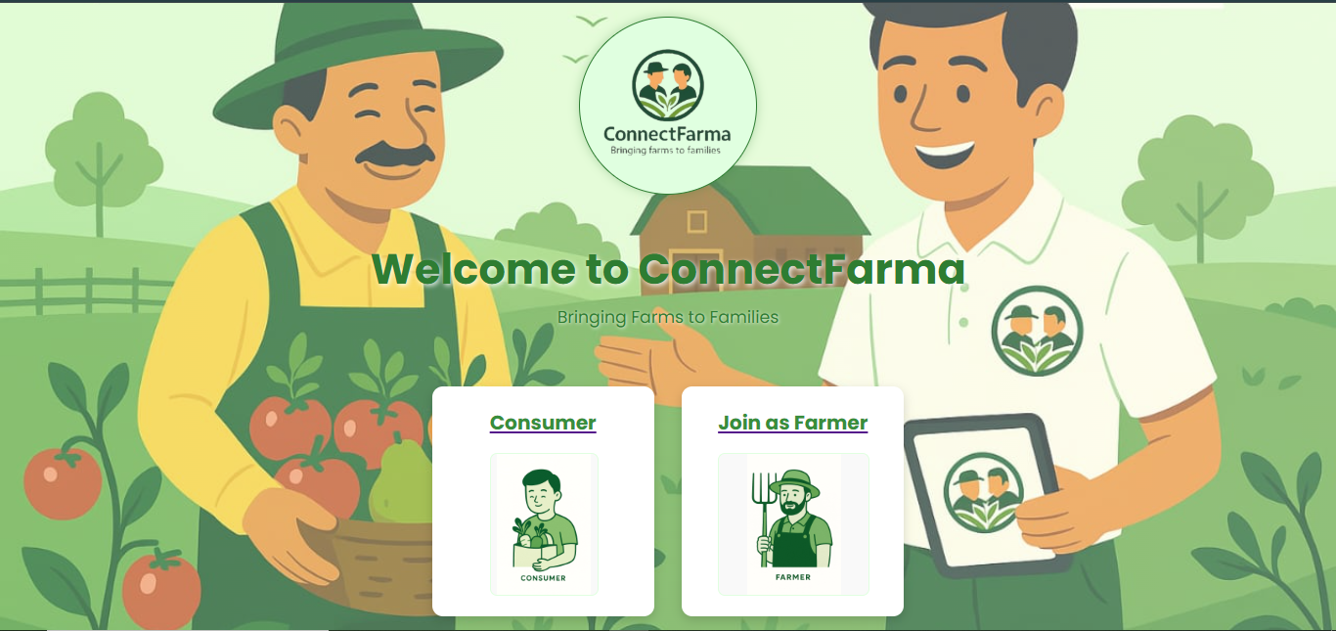

* **Homepage displaying welcome message with options to ‘join as consumer or farmer’.**

1. **Consumer Signup**

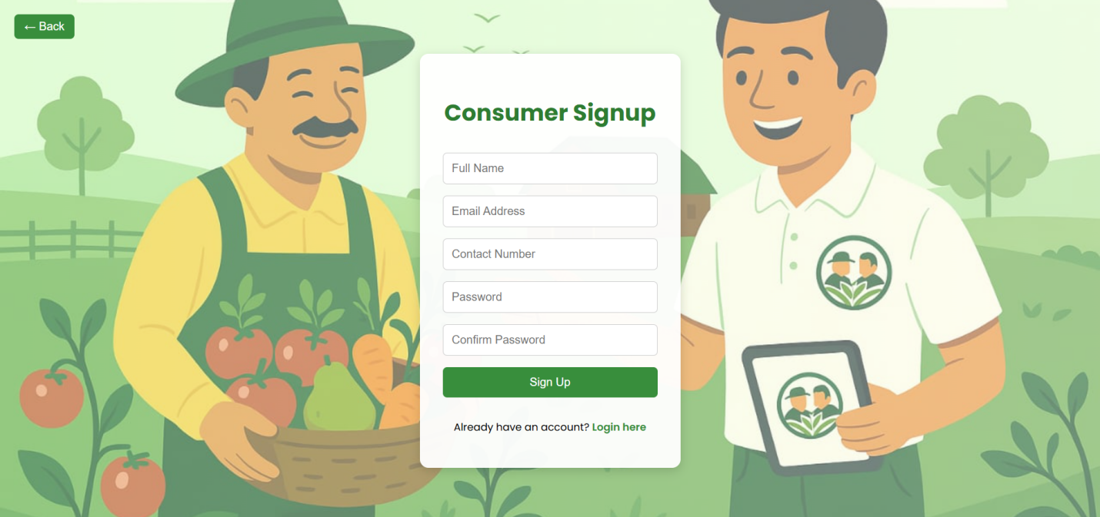

* **Consumer signup page with form fields to register new users.**

1. **Sign Up Credentials**

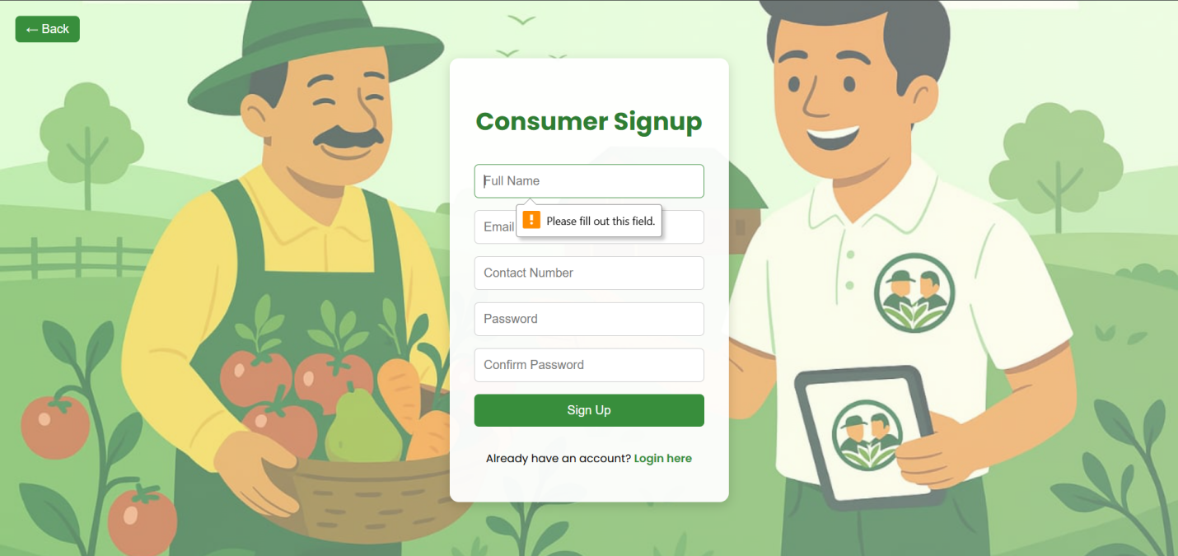

* **Consumers fills in signup credentials to register.**

1. **Sign Up Message**

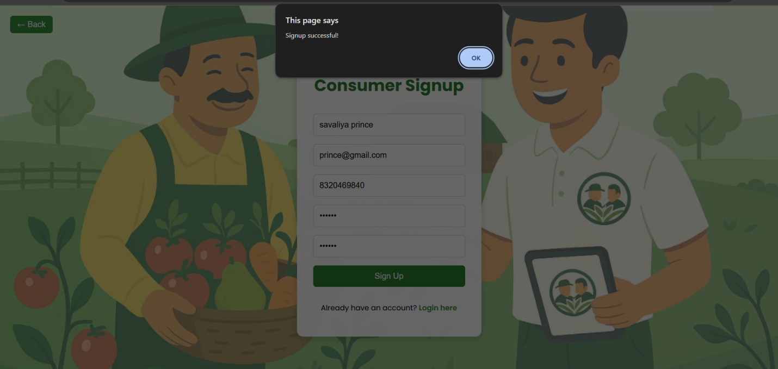

* **Confirmation message appears after successful consumer signup.**

1. **Consumer Login page**

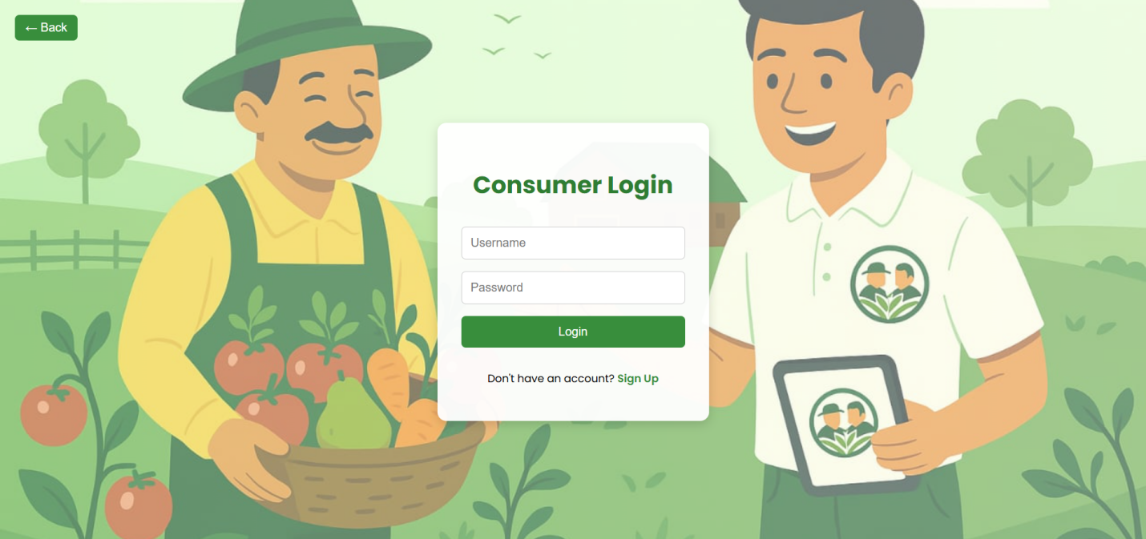

* **Consumer login form to access their account.**

1. **Login Credentials**

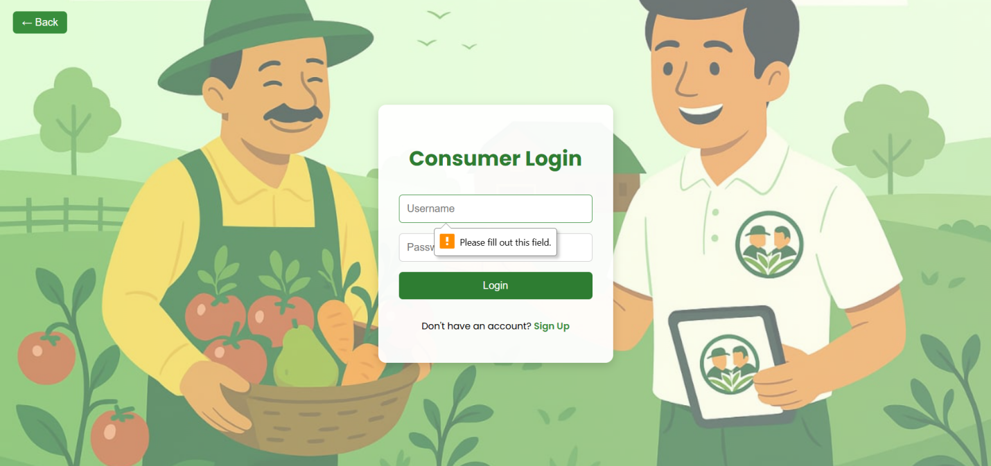

* **Consumer enters their login credentials to proceed.**

1. **Login Detail**

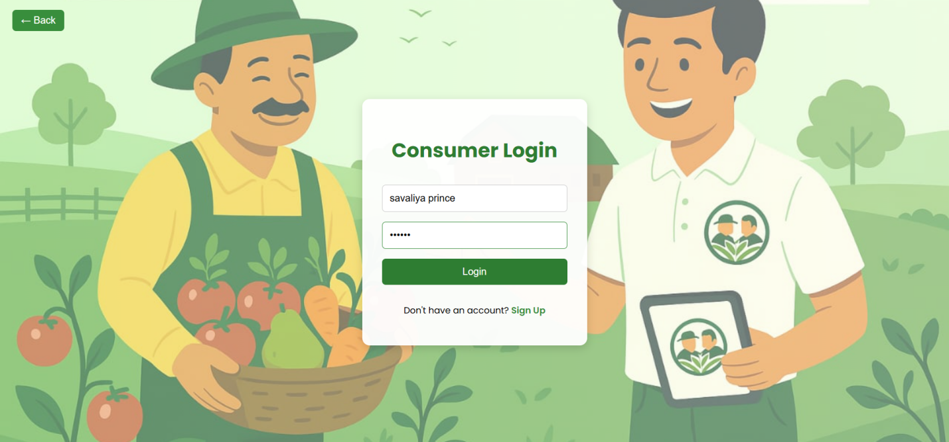

* **Consumer logs in using their email and password.**

1. **Consumer’s Home Page**

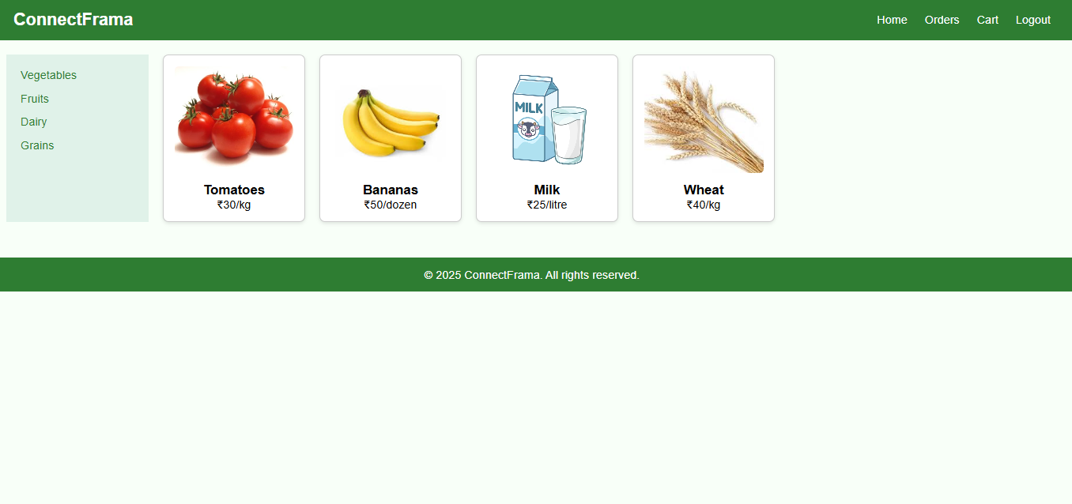

* **Consumer dashboard showing available products like vegetables, fruits, dairy and grains.**

1. **Farmer Sign Up Page**

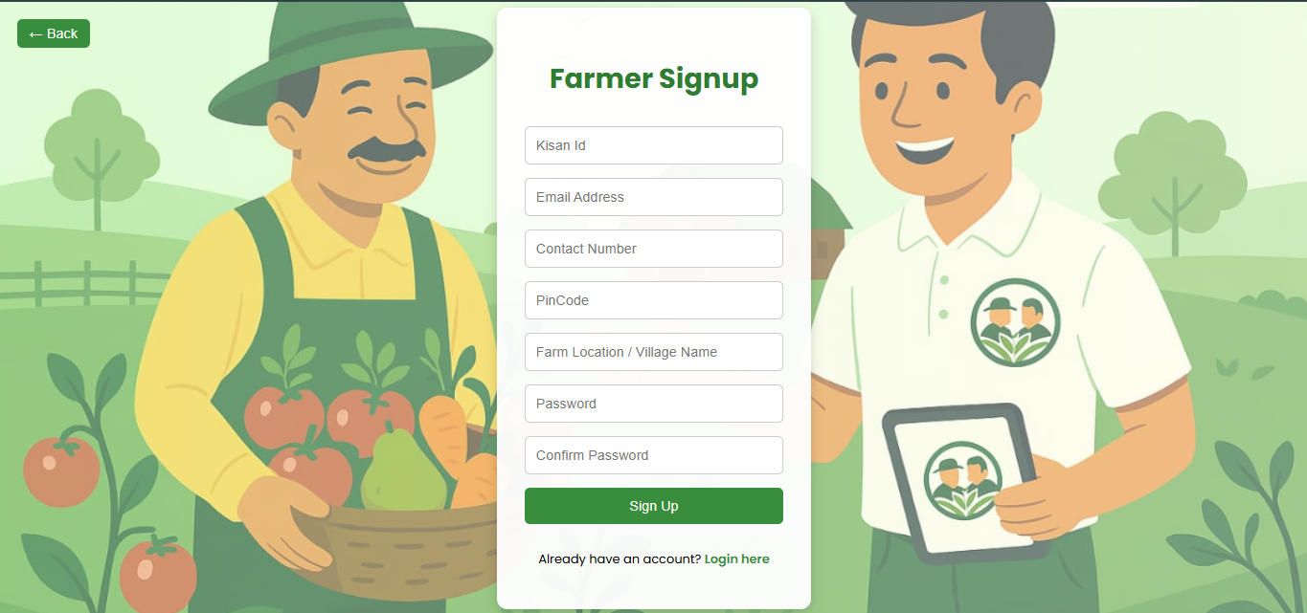

* **Farmer signup page allowing farmers to register on the platform.**

1. **Farmer Sign Up Credentials**

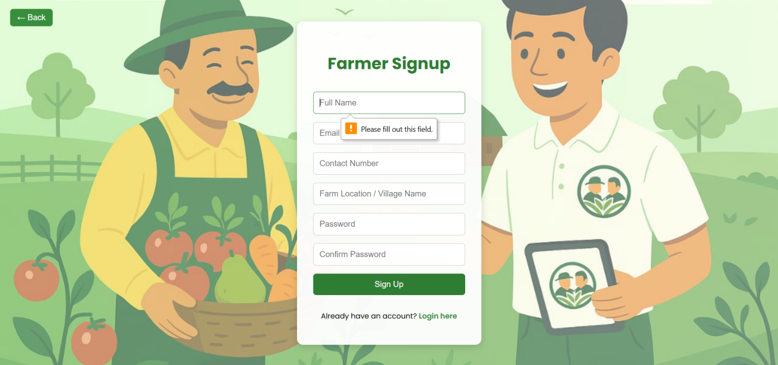

* **Farmer enters personal and location details to create an account.**

1. **Farmer Sign Up Success Message**

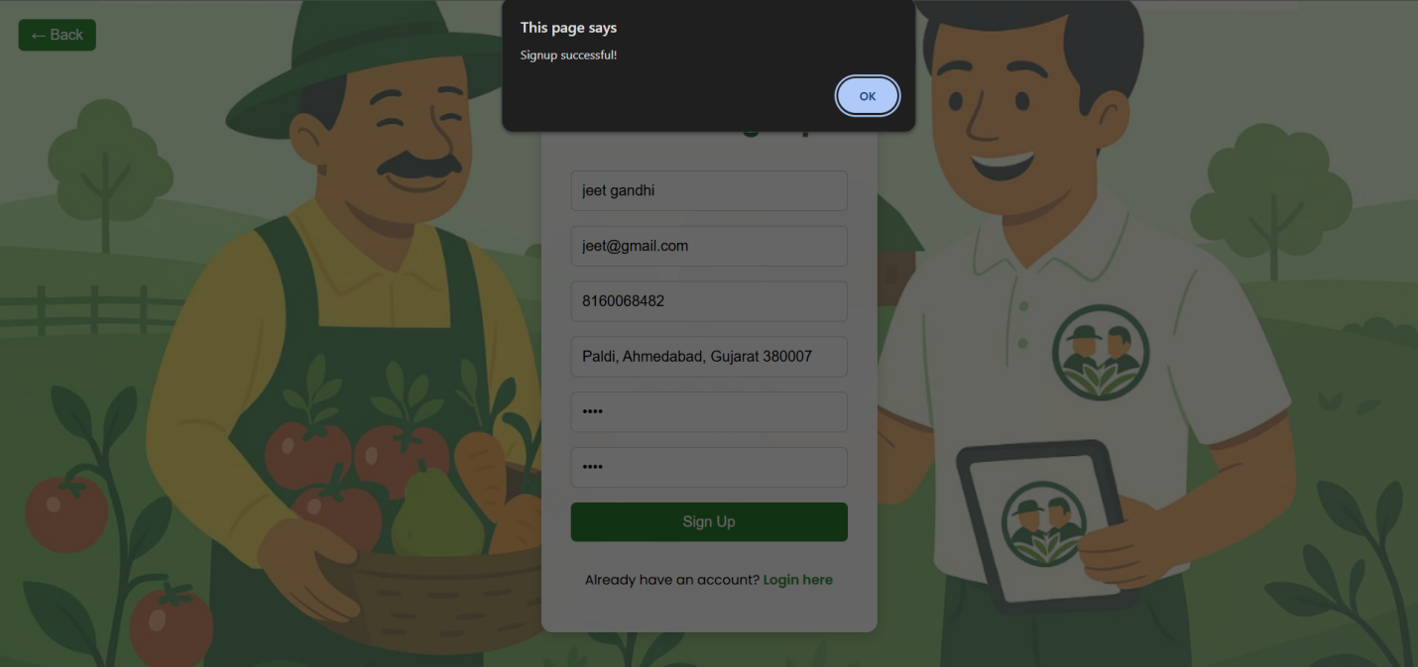

* **Confirmation message after successful farmer registration.**

1. **Farmer Log In**

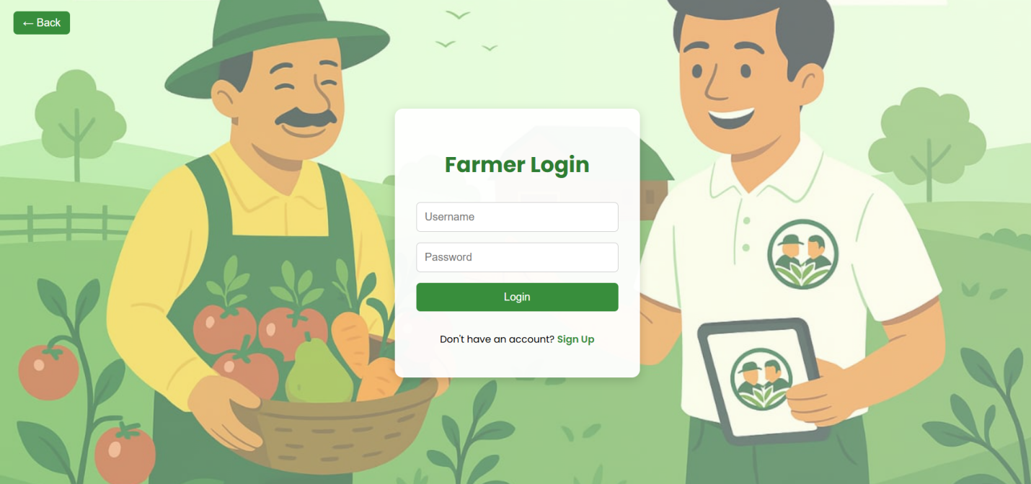

* **Farmer login page to access their profile.**

1. **Log In Credentials**

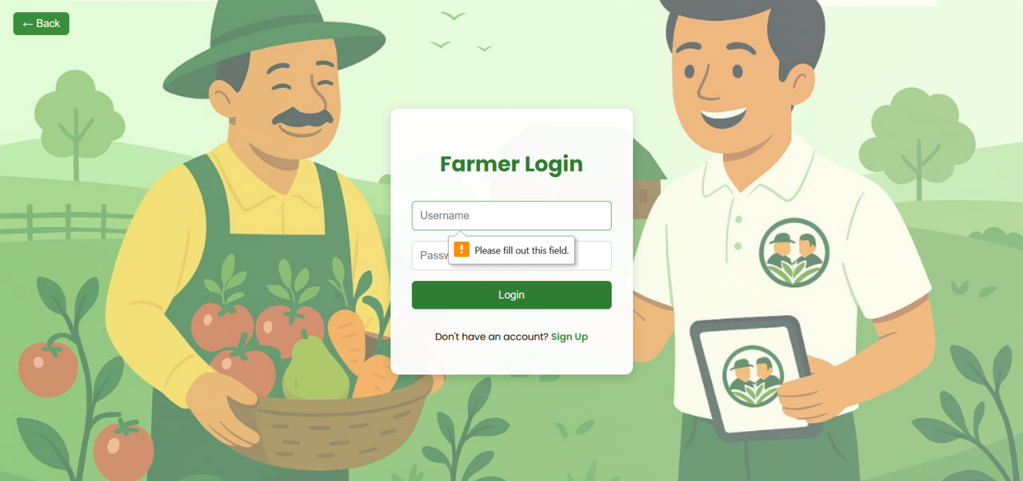

* **Farmer inputs login credentials for authentication.**

1. **Login Done**

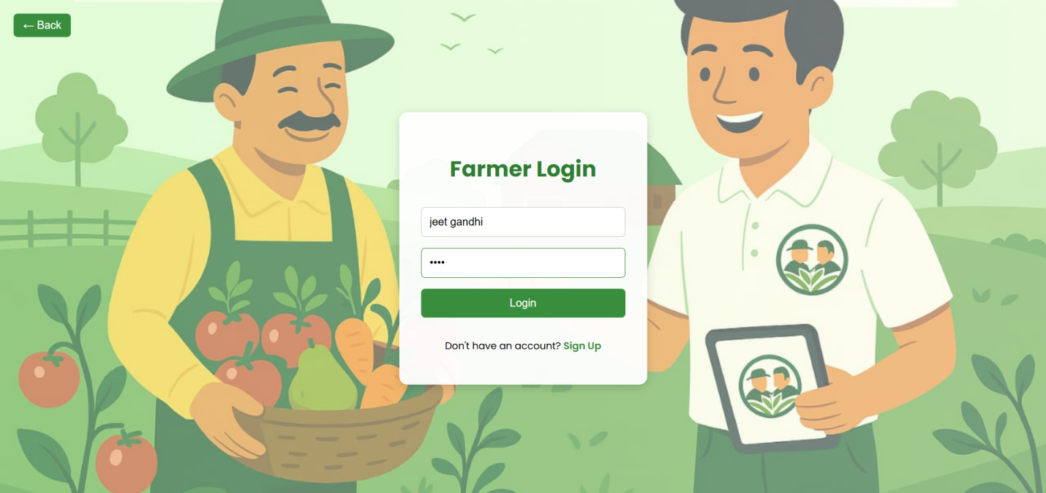

* **Farmer successfully logs in and accesses the platform.**

**Data Development**

**ER Diagram:**

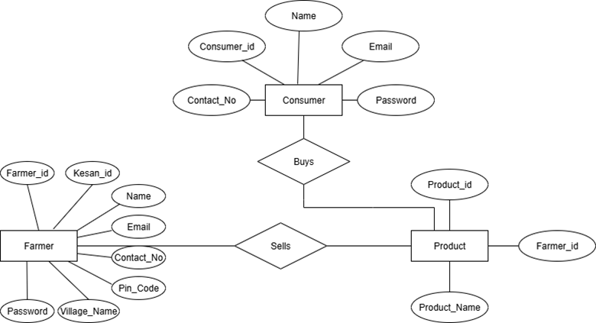

**Database Dictionary**

|  |  |  |  |  |
| --- | --- | --- | --- | --- |
| **Column Name** | **Data Type** | **Data Size** | **Constrains** | **Description** |
| consumer_id | Int(11) | 11 | Primary Key | Unique ID for each consumer |
| name | Varchar(30) | 30 | Not Null | Name of consumer |
| email | Varchar(30) | 30 | Not Null | Used for login & contact |
| contact_no | Int(10) | 10 | Not Null | Phone number for contact |
| password | Varchar(100) | 100 | Not Null | For secure login |

1. **Consumer Table :**
2. **Farmer Table :**

|  |  |  |  |  |
| --- | --- | --- | --- | --- |
| **Column Name** | **Data Type** | **Data Size** | **Constrains** | **Description** |
| farmer_id | Int(10) | 10 | Primary Key | Unique ID for each farmer |
| kisan_id | Int(13) | 13 | Not Null | Govt ID for farmer verification |
| name | Varchar(50) | 50 | Not Null | Name of farmer |
| email | Varchar(50) | 50 | Not Null | For login or communication |
| contact_no | Int(10) | 10 | Not Null | Farmer’s phone number |
| pincode | Int(07) | 07 | Not Null | Farmer’s area code |
| village_name | Varchar(100) | 100 | Not Null | Farmer’s village location |
| password | Varchar(100) | 100 | Not Null | For secure login |

**3. Product Table :**

|  |  |  |  |  |
| --- | --- | --- | --- | --- |
| **Column Name** | **Data Type** | **Data Size** | **Constrains** | **Description** |
| product_id | Int(10) | 10 | Primary Key | Unique ID for each product |
| farmer_id | Int(10) | 10 | Foreign Key | Links product to farmer |
| product_name | Varchar(100) | 100 | Not Null | Product name or title |

**Flow Diagram**

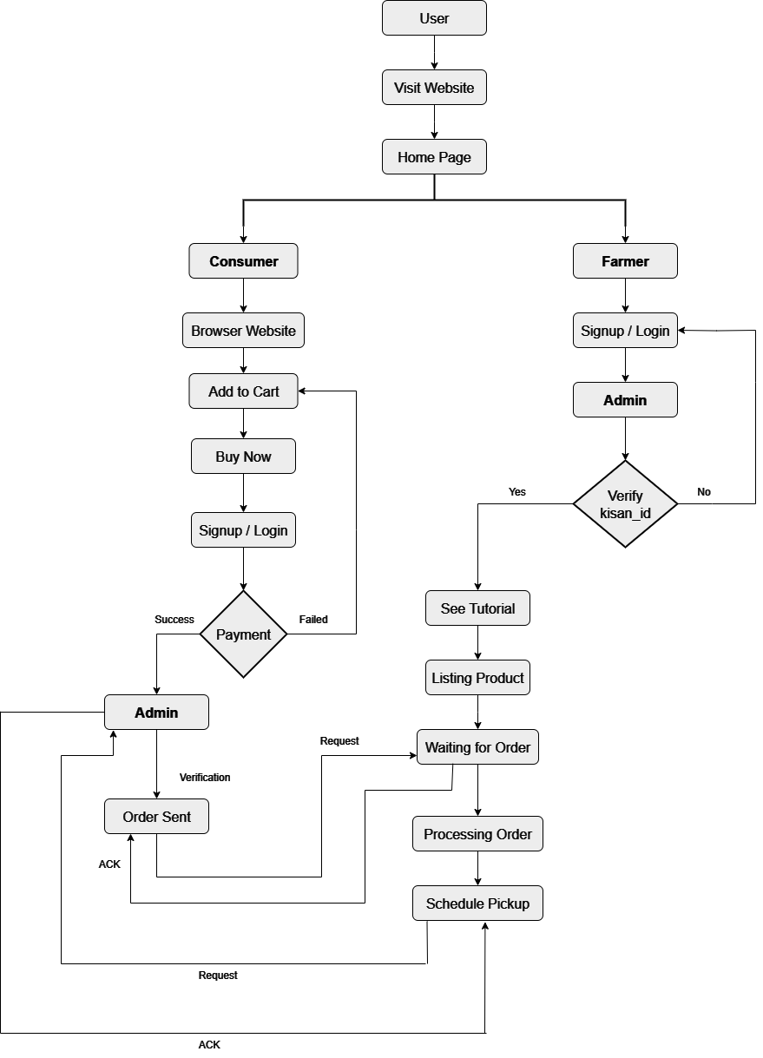

D

**Activity Diagram**

